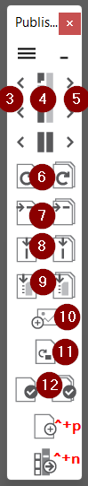

**Esc** – Select column

**F2** – Edit text

**Ins** – Extend selection

Double-tap for “keep going”:

**F3,F5,F6,F7,F8,F9,F12**

**F6** will move to next page  
before adjusting, unless any

modifier is used. E.g. Ctrl

Ctrl+Shift+P

Ctrl+Shift+N